**On Development of a Green Web-based System for Reducing**

**Waiting Times of Outpatients**

A Thesis Submitted to the College of

Graduate Studies and Research

In Partial Fulfillment of the Requirements

For the Degree of Master of Science

In the Department of Biomedical Engineering

University of Saskatchewan Saskatoon

by

Feng Dai

Copyright Feng Dai, November, 2015. All rights reserved.

**PERMISSION TO USE**

In presenting this thesis in partial fulfillment of the requirements for a Postgraduate degree from the University of Saskatchewan, I agree that the Libraries of this University may make it freely available for inspection. I further agree that permission for copying of this thesis in any manner, in whole or in part, for scholarly purposes may be granted by the professor or professors who supervised my thesis work or, in their absence, by the Head of the Department or the Dean of the College in which my thesis work was done. It is understood that any copying or publication or use of this thesis or parts thereof for financial gain shall not be allowed without my written permission. It is also understood that due recognition shall be given to me and to the University of Saskatchewan in any scholarly use which may be made of any material in my thesis.

Requests for permission to copy or to make other use of material in this thesis in whole or part should be addressed to:

Head of the Department of Biomedical Engineering

University of Saskatchewan

Saskatoon, Saskatchewan (S7N 5A9)

ABSTRACT

Outpatients have to wait for several hours in hospitals to see doctors in some countries or regions. This is existed in China, while in Canada, this may happen in a walk-in clinic center. Though there is no life-threaten issue with patients in this context, outpatients have to waste hours to wait in hospitals or clinic centers, and these hours may otherwise be used for meaningful activities. Therefore, how to reduce the waiting time of outpatients is a meaningful issue in health service systems worldwide. This thesis presents a study to address this issue.

A straightforward idea to solve this problem is to have a web-based system that allows the outpatient to communicate with a health service system at home, office, or even on travel with devices such as cell phones. Then the system would assign the particular patient to the particular hospital and inform this assignment to both of them. Such a web-based system is essentially an interface system for patients, doctors and hospitals.

The overall objective of this study was to develop a web-based (interface) system for the reduction of the waiting time (the earliest time the patient sees the doctor as the patient desires) of outpatients. The specific objectives of the study include: **Objective 1**: to develop the architecture of such a web-based system with the goal that the system is extendable. **Objective 2**: to develop an algorithm for the assignment of the patient to the hospital to reduce both the waiting time of outpatients and the transportation time of outpatients from a particular location to a particular hospital with the goal that the algorithm is scalable. **Objective 3**: to build a demonstration system to validate both the web-based interface system concept and the assignment algorithm. The design methodology for developing such a web-based interface system was also explored in this study.

The study has concluded: (1) a design methodology to develop the architecture of a web-based system which is extendable (2) a scalable algorithm which can assign patients to hospitals with a goal that minimal the waiting time of outpatients and transportation time. (3) a demonstration system which can validate both the web-based interface system concept and the algorithm with its design methodology.

The main contributions of the thesis are: (1) the provision of the architecture of a web-based system (for the patient, doctor, hospital) that can reduce the waiting times of outpatients, (2) the provision of the novel algorithm for scheduling the patient to the hospital with both the shortest waiting time of outpatients and the shortest transportation distance of outpatients from their locations to a particular hospital; and (3) the construction of a prototype of the web-based system with the aforementioned two enablers, which can also be used as a test-bed for other applications such as algorithms for scheduling in the health service system.

ACKNOWLEDGEMENTS

I would like to express my greatest appreciation to my supervisor, Professor W.J. (Chris) Zhang for his guidance and support. What he gives me are not only in academic but also in many other aspects in my life. I learned a lot from him and I am also proud as one of his students.

I appreciate the help of Dr. Bin Han for professional suggestions as a doctor in University of Saskatchewan. I also would like to express my gratitude to my fellows in our laboratory, namely Xiaohua Hu, Dong He, Ang Chen, Yu Zhao, Mengya Cai and Haili Lu. Their suggestions are valuable to the completion of my thesis.

I am grateful to both my parents and other family members for the financial support and encouragement on my study and life. Lastly, a special thanks to my girlfriend, Jun Di. You are the one who knows me, supports me and encourages me understand the joy of life.

DEDICATION

To my parents:

Weimin Yang and Zhihe Dai

TABLE OF CONTENTS

PERMISSION TO USE ii

ABSTRACT iii

ACKNOWLEDGEMENTS v

TABLE OF CONTENTS vi

LIST OF FIGURES viii

LIST OF TABLES x

LIST OF ABBREVIATIONS xi

1 INTRODUCTION 1

1.1 Background 1

1.2 Motivation 1

1.3 Objectives and scope 4

1.4 Organization of the thesis 5

2 BACKGROUND AND LITERATURE REVIEW 7

2.1 Introduction 7

2.2 Characteristics of the Web-PHVA system 7

2.3 The current development methodology for Web-based Systems 9

2.4 Unsuitability of the current software development methodology 11

2.5 The current solution to the waiting time of patients 12

2.6 Concluding remarks 14

3 SYSTEMS DESIGN METHODOLOGY 15

3.1 Introduction 15

3.2 General ideas for ICD-methodology 15

3.2.1 Scope of the system to be designed regarding Web-PHVA 15

3.2.2 Philosophy for the ICD-methodology 16

3.3 ICD-methodology - steps 17

4 THE ARCHITECTURE OF WEB-PHVA 19

4.1 Introduction 19

4.2 The mental model of the patient – the domain model for Web-PHVA 19

4.2.1 The FCBPSS model of the health service system in a town 19

4.2.2 The UML model of the health service system 23

4.3 The requirement model of Web-PHVA 25

4.4 The architecture of the Web-PHVA 26

4.5 Conclusion with discussion 27

5 SCHEDULING OF OUTPATIENTS 28

5.1 Introduction 28

5.2 Problem description and general idea 28

5.3 Problem assumption 29

5.4 Mathematical model 29

5.5 Algorithm 32

5.6 Results with discussion 32

5.7 Conclusion 38

6 DEMONSTRATION SYSTEM: VALIDATION 39

6.1 Introduction 39

6.2 Conceptual design of the demo system of Web-PHVA: revisiting 39

6.3 The layout for the Web-PHVA system 40

6.4 The scenario of the Web-PHVA 42

7 CONCLUSION 45

7.1 Overview 45

7.2 Contributions 46

7.3 Future work 47

REFERENCES 48

APPENDIX A 53

APPENDIX B 54

APPENDIX C 56

LIST OF FIGURES

Figure 2.1 General situation of the problem to be solved 8

Figure 2.2 Waterfall model ["Waterfall model" 2016] 11

Figure 2.3 Prototyping model [Istqb exam certification 2016] 11

Figure 4.1 Flow chart of the service 22

Figure 4.2 UML object model of the health service system 23

Figure 4.3 UML activity model of the health service system 24

Figure 5.1 Computational time of NSGA-II 34

Figure 5.2 The locations of the patients and hospitals 36

Figure 6.1 Layout of Gadget-1 40

Figure 6.2 Detailed design of Gadget-1 41

Figure 6.3 Layout of Gadget-2 and Gadget-3 41

Figure 6.4 Detailed designs of Gadget-2 and Gadget-3 42

Figure 6.5 Locations of patients and hospitals in a city 43

Figure 6.6 The movements of the patients 44

Figure 6.7 Schedule of the patients 44

Figure A.1 Categorized diagrams in UML [“Unified Modeling Language” 2015] 53

Figure B.1 Hierarchical systems of the functional requirements and design parameters [Shin et al. 2005] 55

LIST OF TABLES

Table 5.1 Parameters of the algorithm 43

Table 5.2 Computational time of NSGA-II 45

Table 5.3 Reservation records example 48

LIST OF ABBREVIATIONS

ADT

API

AT

CO

CR

CT

DP

DT

FBS

FCBPSS

FR

FTT

ICD

IS

MRI

NSGA

OO

OPWT

PAES

PHVA

PRT

RAD

SDP

SOC

SPEA

UML

Axiomatic Design Theory

Application Program Interface

Assigned Time

Carbon Dioxide

Condition Requirement or Context Requirement

Computed Tomography

Design Parameter

Departure Time

Function, Behavior, Structure

Function, Context, Behavior, Principle, State, Structure

Function Requirement

Fast Track Treatment

Interface Cybernetics Design

Infrastructure System

Magnetic Resonance Imaging

Non-dominated Sorting Genetic Algorithm

Object-oriented

Outpatient Waiting Time

Pareto Archived Evolution Strategy

Patient Hospital Visiting Assistance

Patient Required Time

Rapid Application Development

Systematic Design Process

Specialist Outpatient Clinics

Strength Pareto Evolutionary Algorithm

Unified Modeling Language

# CHAPTER 1 INTRODUCTION

## 1.1 Background

There are many reasons for dissatisfaction in outpatient clinics. Waiting time is one of them [Uehira & Kay 2009, Barlow 2002, Bielen & Demoulin 2007]. Excessive waiting time is an important area of complaints from patients [Clague et al. 1997]. Also, waiting time is a non-value added time in the health service system, as during the period of waiting, no direct value of service is created [Kujala et al. 2006], and waiting time also makes patients lose valuable time in hospitals [Barlow 2002].

**According to** Pillay et al. [2011]**, patients wait for more than two hours on average from the registration to getting the prescription slip, while the contact time with the medical personnel is only on average 15 minutes. Further, a five-country hospital survey by Blendon et al. [2004] found that Canada, Britain and USA reported the average waiting times of** **two hours or more. In Britain, the waiting time is 30 minutes according to the Patient’s Charter, although the reality may be quite different. On many occasions, the strain due to waiting for a long period has even led to verbal aggression by patients towards nurses or clinic receptionists [Bolton 2002].**

## 1.2 Motivation

Zhang [2012] described the conventional process of seeing doctors in hospitals in Mainland China as follows:

Step 1: Registration

Patients need to register in a health service system of a town or district for seeing doctor. It is the patient’s responsibility to describe initial symptoms to decide which specialized department the patient should go. After the patient registers, the patient gets a piece of paper showing which room the patient should go to, a card (including the patient’s personal information) and a blank booklet. It is common that the patient spend around 20 minutes [Healthcare Performance Partners 2010] to get the registration done.

Step 2: Waiting for meeting with doctor

Patients need to wait for about **two hours or more in hospital [Blendon et al. 2004]** in order to meet with doctor.

Step 3: Medical test

The doctor may suggest some medical exam, e.g., blood test, in order to make diagnosis and recommend treatment on the patient. To take a blood test, the patient needs to go to the laboratory department with the first step to register, the second step to do tests and finally to get testing results. The blood test may take (wait primarily) about one hour to two hours, while the MRI (Magnetic resonance imaging) test may take (wait primarily) about two to three hours.

Step 4: Go back to the doctor

Go back to the doctor with the result of the medical examination, e.g., blood test. The doctor may take about five minutes to complete the diagnosis and prescribe drugs if necessary.

Step 5: Wait for the printing of medical records

The doctor will take about five minutes to write a report of the diagnosis and prescription on the booklet which records each visiting to the doctor by the patient.

Step 6: Pay the fee to the hospital for the doctor’s service

Step 7: Get the drugs from the pharmacy

The pharmacy is within the hospital. The average wait time for getting the drugs is about 45 minutes, estimated according to [Wieczner 2013].

As it can be seen from the above, patients spend all of the time in the hospital from Step 1 (get Registration) to Step 7 (Get drug). Particularly, a significantly long waiting time takes place in Step 1, Step 2, and Step 7, and also, the situation requires a large space of the hospital to hold patients.

This study was motivated by reducing the Outpatient Waiting Time (**OPWT**). Reducing the OPWT is not only meaningful to improving the quality of the health-care service system but also is to having a good mood with outpatients (as the patients do not like to stay in hospitals but office or home environments).

A general research question was posed:

*How to reduce the waiting time of outpatients to a minimum?*

The ideal situation is that the patient has a desired time window to see doctor and the patient is assigned to see doctor in the earliest time with reference to the desired time window. Therefore, obviously one needs to analyze what activities that may be done outside the hospital. With the modern telecommunication and information technology, it may be clear that the following activities can be done definitely outside hospitals and even at home or office:

* Waiting for registration (step 1).
* Waiting to meet with doctor (step 2).
* Waiting to get drugs and getting drugs (step 7).

Therefore, the general question was changed:

*How to develop a web-based system to reduce the waiting time of patients to a minimum?*

There is a possibility that the waiting time of patients may be reduced but the idle time of doctors in hospitals may increase. For instance, doctors would wait patients to come, while patients would only schedule to come. Further, when there is a conflict between the waiting time of patients and the idle time of doctors, leaving no idle time of doctors is taken as a higher priority than leaving no waiting time of patients. Therefore, the final version of the research question is:

*How to develop a web-based system to reduce the waiting time of patients to a minimum while keeping doctors with no idle time?*

This research further assumed the context that there are many hospitals to be accessed by many patients instead of one hospital to many patients in a town or region. This assumption is in fact the case of the city of Saskatoon in Canada, the city of Shanghai of China, etc. Under this assumption, the question of how to reduce the patient’s waiting time becomes how to find the earliest time for the patient with reference to the desired time window given by the patient. As a side problem, in this case, the transportation time of patients to hospitals was also a factor to be considered, and this factor was taken into account in this thesis. Particularly, there may be several options to a patient in terms of different hospitals, all of which can meet the expectation of patients to see doctor; in this case, the option with the shortest distance from the patient’s home or office to the assigned hospital will be eventually chosen. The shortest distance implies the least use of the transportation vehicle and the least production of CO2 gas, and from this point of view, the research outcome will also contribute to a green society or community.

## 1.3 Objectives and scope

In summary, the research problem can be stated as: to schedule or assign a patient to a hospital to achieve the minimal waiting time of outpatients, where the waiting time is the time difference between the time the patient actually meets the doctor and the earliest desired time suggested by the patient, and in the meantime to achieve the shortest transportation distance of outpatients to hospitals. The solution concept to this research problem is a web-based system with a scheduling algorithm. A systematic approach, especially systematic design approach to systems [Fan et al. 2015], was proposed to develop this web-based system. As such, the specific objectives for this research were proposed as follows:

**Specific objective 1**: to develop the architecture of a web-based (interface) system for reducing OPWT with the goal that the web-based system is extendable. For the convenience of later discussions, this web-interface system is called **Web-PHVA** (**PHVA**: patient hospital visiting assistance). It is noted that the Web-PHVA system is essentially an interface system upon the internet, which further contacts various mobile or non-mobile end-user devices such as cell phone. However, this thesis was not intended to study interface technologies with the end-user devices.

**Specific objective 2**: to develop an algorithm for scheduling of the patient to the hospital such that both the OPWT and the transportation distance of the patient to the hospital can be as short as possible. The algorithm was expected to be scalable.

**Specific objective 3**: to build a demonstration system such that both the web-based system and algorithm developed in the first two objectives can be validated.

Further, in the author’s preliminary study, the author also found that a rational and systematic approach to developing the system like Web-PHVA seems to be missing. Therefore, attention was also paid to this missing knowledge in this thesis.

## 1.4 Organization of the thesis

This thesis consists of 7 chapters (including the current chapter, Chapter 1). **Chapter 2** discusses some basic concepts as well as the literature relevant to the proposed research for the purposes of (1) laying a foundation for successfully performing the research to meet the objectives and (2) further confirming the need of the proposed research objectives. **Chapter 3** presents a systematic approach to construct a system like Web-PHVA, which is a kind of the cybernetic interface system (more will be provided in later discussions). **Chapter 4** presents the architecture of the Web-PHVA system. The architecture of the system will be analyzed for the extendibility requirement. **Chapter 5** presents an algorithm to perform the optimal assignment or scheduling of a patient to a hospital. **Chapter 6** presents the work of developing a demo Web-PHVA system to give an impression of the Web-PHVA system. An agent-based simulation system development tool was used to implement this demo system. **Chapter 7** concludes the thesis with discussion of the research results, contributions, and future work.

# CHAPTER 2 BACKGROUND AND LITERATURE REVIEW

## 2.1 Introduction

This chapter will provide more background and discuss the nature of the research so as to justify the need and urgency of the proposed research as presented in Chapter 1. In particular Section 2.2 provides a discussion of characteristics of the Web-PHVA system. Section 2.3 gives an overview of the current software development methodology. Section 2.4 puts an argument of why the current software development methodology does not suit the development of Web-PHVA. Section 2.5 provides a review of the state of knowledge to address the issue of the waiting time of patients. Finally, there is a discussion of the need and urgency of the proposed research in Section 2.6.

## 2.2 Characteristics of the Web-PHVA system

Figure 2.1 shows the general situation of the problem to be solved by Web-PHVA system. In this figure, there are several patients and there are several hospitals. A management system (e.g. Web-PHVA) is supposed on the top of them, which essentially facilitates the communication between the patient and hospital. Generalizing the situation of Figure 2.1, the patient is a kind of client, the doctor is a kind of service provider (the other kind of service provider is the machine or equipment such as CT which is further operated by support personnel), and the hospital is a kind of service center. In this thesis, the service provider and service center are put together called service. The three entities: clients, doctors, hospitals all have the attributes of time (working hours) and space (or location). Their communication is in the form of signals, perhaps transmitted through the internet of telecommunication systems (e.g., cell phone). For instance, while a client is in motion, a phone call comes to him or her to direct him to go to a particular service center and to meet a particular service provider. When the client arrives at the service center, his physical state (e.g., location) is registered in a corresponding management system (i.e., PHVA).

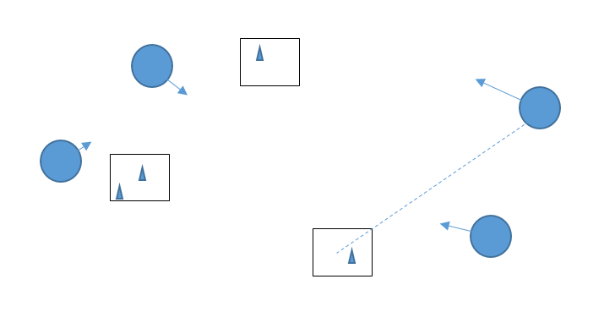

Hospital

Patient

Doctor

Figure 2.1 General situation of the problem to be solved

The characteristics of such systems are:

* The service center is fixed in location.
* The client may move around to communicate with the service center.
* The client may receive signals from the service system (service provider and service center).
* The client may change his required time window to see doctor. This change behavior may be due to an incoming signal or message to the client or due to the change of the structure of client’s cognition and emotion system (brain and heart).
* One service center can serve for many clients.
* The client and service provider may not directly communicate with each other, and instead they communicate via a coordination system (e.g. web-PHVA).
* The service provider trusts the coordination system.
* The service provider has a capacity limit in terms of service items and space and time.
* The service center may have many types of services.
* The client may have many different requests to the service system.
* The client may use mobile devices to communicate with the coordination system.

It is noted that a system with the above characteristics may also be called **cybernetic system** or internet-based service supply system; a comprehensive definition of service system is referred to Wang et al. [2014]. A simple understanding of the cybernetic system in this thesis is as this; a system is called cybernetic system if it has the following features: (1) the system contains both humans and devices, (2) dynamics of the system is co-governed by the brain of humans and controller of devices, (3) the system is a network with multiple in-nodes and multiple out-nodes to the environment which co-exists with the system, and (4) the system has many “soft” boundaries with the environment. In fact, the Web-PHVA system is a kind of interface of a cybernetic system with several management functions.

## 2.3 The current development methodology for Web-based Systems

For modern web-based systems, the three-tier architecture of systems is effective, which logically separates an entire system into three layers: presentation, application processing, and data management function ["Multitier architecture" 2015]. The presentation tier allows the user (e.g., patients in Web-PHVA) to communicate with the service system (e.g., hospital in Web-PHVA). The application processing tier includes processors for the business concerned for a particular application (e.g., health-care systems in a city). The data tier includes the data stored (persistent or temporary). The three-tier architecture can thus allow the applications (e.g., Web-PHVA) to be run on any computing platform and on any mobile device (e.g., cell phone, laptop, etc.).

It is noted that by separation of the three systems, there must be software systems that automatically maintain the consistency and dependency of data and operations among these systems. These systems may be called program interface system for short, and particularly, the interface system between the data and application is called application interface (**API**). One challenge in developing web-based systems under the service architecture is: how to trade-off between the flexibility of the system and performance of the system. However, this challenge is out of the scope of this thesis.

Viewing the Web-PHVA as a software system, there are many methods available for the software system development, notably object-oriented, Waterfall, Prototyping, Incremental and Rapid Application Development (**RAD**).

The Object-oriented (**OO**) based software development method takes the philosophy that a software system has its structure and behavior, and the two must be treated as one called object. Therefore, the OO approach suggests that the first step in developing a software system be to identify the objects in the sense of the OO philosophy in a domain of application, which is often a task called data modeling or semantic data modeling. The second step is to develop a specific process for a specific application. The third step is to develop a specific process control system for a specific application. It is noted that to facilitate these three modeling activities, Unified modeling language (**UML**) is an effective tool. The OO approach advocates the modular system architecture [Bi et al. 2010] and the development of a software system can be run in parallel or concurrently. UML can be found in Appendix A for facilitating the reader of this thesis.

The waterfall model or approach advocates a sequential design process, in which a progress is seen as flowing steadily downwards (like a waterfall) through the phases of conception, initiation, analysis, design, construction, testing, production/implementation and maintenance (Figure 2.2). This process is very much like the process of developing hardware products or systems.

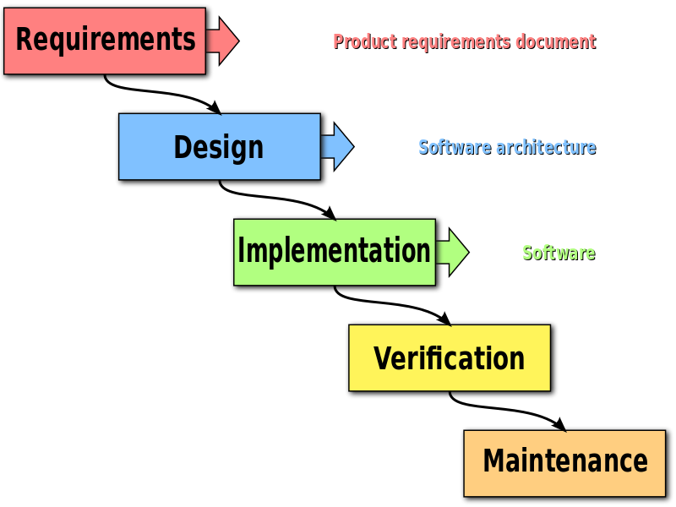

Figure 2.2 Waterfall model ["Waterfall model" 2016]

The basic idea of the prototyping model is to construct a prototype of system and test it rapidly (Figure 2.3). This happens in two situations. The first situation is that the requirement to have a system is uncertain. The second situation is that the coding of the system may not be possible in terms of the space and time complexity. For both the situations, having a “real” system to test it is certainly an effective method to cope with the uncertainty.

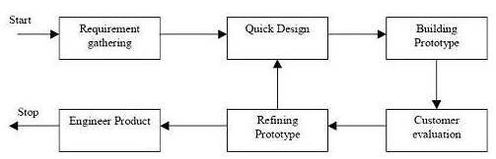

Figure 2.3 Prototyping model [Istqb exam certification 2016]

## 2.4 Unsuitability of the current software development methodology

Section 2.2 shows that Web-PHVA is essentially a dual interface system which includes both software and hardware (mobile devices with the patients). From the discussion in Section 2.3, it may be clear that the existing software development approaches do not suit the development of the system like Web-PHVA. The OO approach does not have the notion of modeling of human behaviours, and besides, the close binding of the structure and behaviour makes the development process less flexible due to the coupling nature in the structure and behavior. The Waterfall approach is not suitable to the development of Web-PHVA as it is too general to be useful as a general guideline to follow. The prototyping approach is not suitable to the development of Web-PHVA, as in the case of Web-PHVA, the requirement is pretty clear, and the uncertainty in terms of the space and time complexity does not seem to be a problem given the current state of the hardware and software in telecommunication technology. In conclusion, a new method is needed for the development of the system like Web-PHVA.

## 2.5 The current solution to the waiting time of patients

A care must be taken that there may be different definitions of the waiting time of outpatients beside the one applicable to this thesis (**Definition I**). For instance, the waiting time of outpatients may be defined as a period of time from the time the patient wants to see doctor to the time the patient actually meets with the doctor (**Definition II**). In fact, the difference between Definition I and Definition II is about the reference time. In Definition I, the reference time is the earliest desired or required time the patient requires to see doctor, while in Definition II, the reference time is the time the patient wants to see doctor. Further, for both definitions, the outpatient’s waiting can be either in hospital or out of hospital. In this thesis, the latter is the case. In the following discussion, the two definitions are not separated.

In literature, effort on reducing the waiting time of outpatients has been taken on two directions. The first direction is analysis of the root problem, and the second direction is development of solutions to solve the root problem. Many studies are on the mix of these two directions.

Lailomthong & Prichanont [2014] developed a discrete event simulation system for the outpatient department to examine the hospital congestion of patients and further developed an appointment system to reduce the congestion problem. It is noted that the congestion problem implies the waiting time problem. Jin et al. [2013] first analyzed the patient arrivals and the actual waiting time of outpatients in hospitals from the historical data at an eye clinic in Singapore. After that, they provided a preliminary simulation based analysis of the effect of the concept of smooth outpatient arrivals with a proposed patient appointment scheduling andservice process**.** An online reservation system for hospitals is an effective solution to reducing the waiting time in hospitals. An example given by Gorman [2014] shows that the Emergency Room (ER) of the Northridge Hospital Medical Center in Southern California has applied an online reservation system to reduce the waiting time of patients. The appointment can be made by using the devices of patients.

To reduce the waiting time of patients in the hospital emergency department, Kaushal et al. [2015] used agent-based simulation to simulate a “fast track” process compared to the standard procedure in some departments. An agent-based simulation tool was proposed in this research to evaluate fast track treatment (**FTT**) in hospital. The tool can be used to study the behavior change of entities and resources in a complex hospital system. The static and dynamic FTT processes are evaluated. The static process uses the ﬁxed duration in the daily hospital operation. In the dynamic process, FTT is triggered based on the current patient waiting time and the state of hospital operations. The simulation results provide details and information for the process of the FTT implementation at the hospital to reduce the patient’s waiting time. Zhu et al. [2012] analyzed the appointment scheduling systems in specialist outpatient clinics (**SOC**) to detect the factors causing a long patient waiting time/clinic overtime. Analysis was aimed to detect the possible factors causing a long patient waiting time/clinic overtime. Improvement settings were proposed based on the detected factors. A simulation model was constructed to test the clinic performance if the improvement settings were applied. Computer simulation was used in forecast and management in the health service Clague et al. [1997]. Areas that have been examined include the bed requirement in intensive care units [Zhu et al. 2012], the change in workload produced by a green consultant appointment [Hayes et al. 2015], the planning of renal services [Pillay et al. 2011, White et al. 2011] and the modeling of waiting lists [Forsberg et al. 2011, Balasubramanian et al. 2010]. Techniques have generally been used to examine large scale management issues. Mathematical models have been used in general practice to optimize appointment intervals [Bowers et al. 2012].

## 2.6 Concluding remarks

From the above discussion, it can be found that the problem of reducing the waiting time of outpatients based on Definition I has not been addressed. Some indirect solutions to this problem may be available, but packaging of these solutions to this problem is not a trivial task. The problem to avoid the congestion of patients’ visiting hospitals is close to the problem in this thesis, but the former concerns primarily the space issue. Though the solution to solve the congestion problem is scheduling of patients in their visiting hospitals, the general goal in scheduling for solving the congestion problem is quite different from the goal of reducing the waiting time of outpatients.

The Web-PHVA is a dual-interface system between the patient and service, and there is not a well-proven approach available to develop such a system. In fact, such an interface system is a mix of hardware and software systems and it consists of mobile devices. The existing design methodology for hardware and design methodology for software do not work for such a system, and this calls for a new approach. The development of such a new approach was considered as a side research objective of this thesis.

# CHAPTER 3 SYSTEMS DESIGN METHODOLOGY

## 3.1 Introduction

Chapter 2 has concluded that there is no suitable design methodology available in literature for the interface system of cybernetic systems (e.g. Web-PHVA). Thus, a design methodology needs to be developed first in order to develop Web-PHVA. This chapter will describe such a design methodology. For the convenience of later discussions, this methodology is in short called **ICD**-methodology (I: interface; C: cybernetics; D: design). Section 3.2 discusses several ideas for developing the ICD-methodology. Section 3.3 presents the full features of the ICD-methodology.

## 3.2 General ideas for ICD-methodology

Design of an interface system for cybernetic system should share a set of core concepts in design of a general product. The first concept is that design is to generate a specification of system components that are ready for implementation or construction. The second concept is that a process of design is divided into several phases from the conceptual to physical or detail. The third concept is that any system under design is to fulfill a set of functions under a set of conditions, and design can be said to propose a system which can fulfill the set of required functions and the set of required conditions. It is noted that the required function and required condition form a so-called **requirement model** which makes sense to both software and hardware development in literature. The required function is thus called function requirement (**FR** for short), and the required condition is thus called condition requirement (**CR** for short).

### 3.2.1 Scope of the system to be designed regarding Web-PHVA

According to the previous discussions, a cybernetic system is a set of humans and artifacts. Artifact refers to both software sub-systems (or components or modules) and hardware sub-systems (or components or modules). A cybernetic system is in fact a network system with nodes that represent humans and artifacts and edges that represent their connection. The level of an interface for cybernetic system follows the level of cybernetic systems. The scope of this thesis is primarily the design of Web-PHVA at this network level.

### 3.2.2 Philosophy for the ICD-methodology

There are several ideas behind the design methodology for an interface system of cybernetic systems, and they are elaborated in the following.

**Idea 1:**

As noted before, Web-PHVA is an interface with its corresponding management system between the client and service provider. Such an interface is generalized in that it is not just “flat” medium display, but including modern telecommunication tools such as cell phones, and so on [Xue et al. 2015]. Such an interface is called generalized interface [Xue et al. 2015]. Further, the generalized interface is on a dual side, that is: client side and service side. For generalized interface, there are two worlds: the client world and service world. The models of the domains or the worlds are needed, and they can be constructed with the tool of FCBPSS. FCBPSS is the general knowledge architecture of any system [Lin and Zhang 2004, Zhang et al. 2011] (F: function, C: context, B: behavior, P: principle, S: Structure, S: State). The **function** is defined as the usefulness of a system. The **behavior** of a system is about the response of the system when it receives stimuli. The **context** is the pre-condition, post-condition, and environment where a structure is placed. The **principle** is the fundamental law with which one can develop a quantitative relation for the state variable. The **structure** represents the meaningful way by which a set of entities are connected with each other. The **states** of the entities are thus quantities or attributes (numerical or categorical) of either physical or chemical domains [Zhang et al. 2011]. FCBPSS evolves from FBS [Gero 1990, Umeda et al. 1990, Chandrasekaran & Josephson 2000, Bhatta & Goel 1994, Zhang 1994]. The model of the domain created with FCBPSS is thus the most general and comprehensive one.

**Idea 2:**

Apply an integrated design approach [Sampath 2014, Zhang et al. 2012] to designing the dual interface of a cybernetic system (e.g. the Web-PHVA system), which combines **ADT** (Axiomatic Design Theory) [Hintersteiner & Nain 1999, Kim et al. 1991] and **SDP** (Systematic Design Process) [Pahl et al. 1984]. ADT has an axiom (Axiom 1) that the FRs should be kept uncoupling or decoupling and DPs should maintain the uncoupling or decoupling status of FRs. Details of ADT can be found from Appendix B. SDP is used to determine DPs in two senses [Hintersteiner & Nain 1999; first is to determine DPs from FRs and second is to check if DPs are compatible to one another. Details of SDP can be found from Appendix B.

**Idea 3**:

There are four phases for the development of the interface of cybernetic systems, e.g. Web-PHVA: Phase I: development of the requirement model, including the two mental models (one for the client and the other for the service provider). Phase II: determination of what information to be displayed on the generalized interface, which is also called the conceptual design [Xue et al. 2015]. Phase III: determination of how to layout the information on the interface medium, which is also called layout design [Xue et al. 2015]. Phase IV: implementation of the gadgets/widgets and the underling process of the widgets on the generalized interface.

## 3.3 ICD-methodology - steps

Step 1:

Develop the mental model of the client and development of the mental model of the service. The models can be constructed with the help of FCBPSS and represented by UML. The first mental model will be used to develop the interface for the client and the second mental model will be used to develop the interface for the service. In this thesis, Web-PHVA has only the interface for the client.

Step 2:

Develop the requirement model for the interface of the client. This includes the specification of FR and CR. It is noted that in the following, the interface always refer so the interface of the client without confusion. In this step, ADT is applied to make sure FRs are independent to each other.

Step 3:

Develop the conceptual model of the web-PHVA. It is noted that the conceptual model of a system under design is also called the architecture of a system (especially software system). The content in the conceptual model for the interface system is about the gadgets or widgets that fulfil the FR and CR as developed in Step 2. In the general product design, this is about the DP at the principle or solution concept level. In this step, ADT is applied to make sure that DPs maintain the independency of FRs.

Step 4:

Develop the layout model of the web-PHVA. This is about the specification of elements that contain the information as expected from the preceding steps on a generalized medium. By generalized medium, it means that not only visual modality but also other modalities such as audio. In this step, SDP is applied to check the compatibility among elements. It is interesting to note that the compatibility principle for hardware system in SDP is close to the compatibly principle in interface design – in particular for layout design [Liu et al. 2015].

Step 5:

Implement the gadgets or widgets and the corresponding process (such as scheduling of patients to visit hospitals).

# CHAPTER 4 THE ARCHITECTURE OF WEB-PHVA

## 4.1 Introduction

In this chapter, the design of the architecture of the Web-PHVA system is presented by applying the design methodology of ICD systems described in Chapter 3. Section 4.2 will present the mental model of the patient and this part is also called the work domain model [Lin & Zhang 2004, Wang et al. 2014]. Section 4.3 will present the requirement model for the Web-PHVA. The requirement model is derived from the work domain model. Section 4.4 presents the architecture of the Web-PHVA from the requirement model. Section 4.5 concludes the chapter.

## 4.2 The mental model of the patient – the domain model for Web-PHVA

A mental model of the patient here refers to what is the health service system in the patient’s mind, and the mental model of the service system is what is the patient’s mind and emotion. In this thesis, only the mental model of the patient was considered. It is noted that the mental model is also called the domain model. According to the design methodology described in Chapter 3, the tools of FCBPSS and UML are employed to develop the domain model.

### 4.2.1 The FCBPSS model of the health service system in a town

**The structure and state**:

The structure of a health service system in a particular context (town, state, country) refers to the following entities which may be at the logical level or physical level of a system:

1. Registration.
2. Patients.
3. Doctors.
4. Hospitals.
5. Drug shops.
6. Location of patients.
7. Location of service centers or hospitals.
8. Doctors providing services in hospitals at a specific time.
9. Internet is available in hospitals and a town.
10. Patients can access the Internet by computer or cell phone.

**The principle**:

There are several principles in the Web-PHVA:

1. The levels of service of all hospitals in a town are the same except their locations.
2. Patients initiate the reservation to see doctors.
3. Patients go to hospitals on their own and with the same travel rate.
4. Patients follow the schedule in time.
5. The duration of time that each patient meets with doctor is the same.
6. The patient pays for the service.

**The behavior**:

The behaviors of the Web-PHVA are:

1. Arrange the patient’s appointment upon the request of the patient.
2. Manage the information of patients upon entering the information by the patient.
3. Receive the patient’s pay online upon the payment issued by the patient.

**The context:**

The context refers to various countries/states with their governments, for example Mainland China with the Chinese government, Canada with the Canadian government, Saskatchewan with the Saskatchewan government. It is noted that the context has effects on the function of a system; for instance, the sub-function of ‘patients get the drug in the hospital’ makes sense in the context of Mainland China but not in Saskatchewan.

**The function**:

The function of a health service system in a town is to provide health-care services (diagnosis, treatment) to the people in the town. There are two classes of services in terms of how urgent the service is needed. The overall function of providing service is decomposed into several steps: (1) patients need to express their requirement to visit doctors, (2) patients meet the doctor, (3) patients pay the fee for the service received, and (4) patients get the drug, prescribed by the doctor, in the hospital.

The procedure of getting services by the patient is a part of the mental model of the patient or a part of the domain model. Figure 4.1 shows a generic flow of services. The knowledge displayed in the figure is self-explanatory. It is noted that Part A in Figure 4.1 is out of the scope of this study, and how the service determines the schedule for the patient in (6) of Figure 4.1 will be discussed in Chapter 5. The next section is a UML model of the health service system.

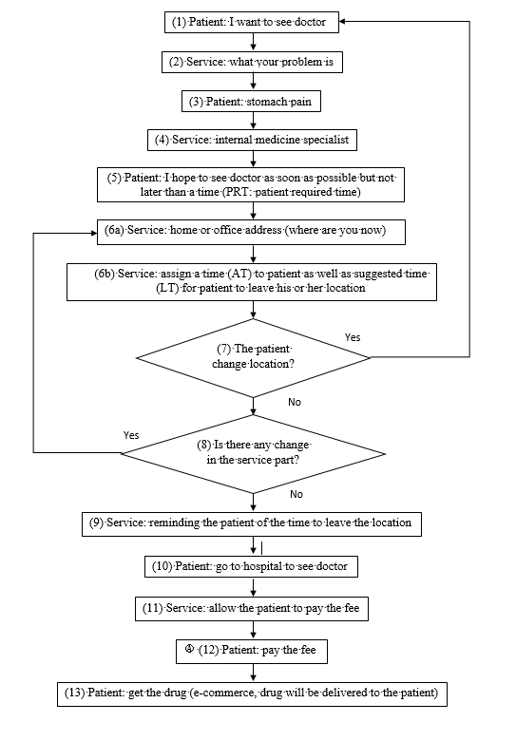

Figure 4.1 Flow chart of the service

### 4.2.2 The UML model of the health service system

Figure 4.2 is a UML model of the main objects in the health service system (i.e., hospital, doctor, drug shop, patient, reservation and record) as well as their relationships. It should be noted that all the relationships make sense at the logical level; for instance one hospital has one drug shop, meaning that at the physical level, it may be possible that many hospitals are associated with many drug shops and patients can access to any drug shop based on again the short waiting time and short transportation time. Figure 4.3 is a UML activity model of the health service system, which captures the semantics as represented in Figure 4.1.

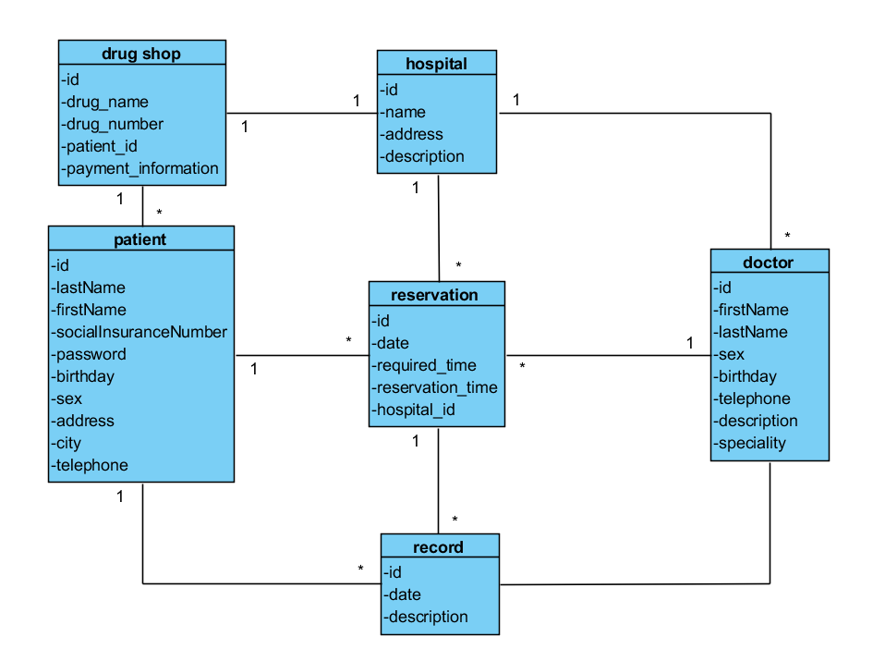

Figure 4.2 UML object model of the health service system

Figure 4.3 presents the UML activity model of the health service system. In this procedure, the user is the patient and the patient interacts with the health service system in a number of steps. First, a patient has to inform the service system that he or she wants to see doctor, and then the patient needs to describe his symptom and specifies the required time window to see doctor. After that, the patient sends the request to the system, which will check whether there is an available hospital and time for the patient to see doctor. If there is no available hospital or available time for the patient, the patient needs to specify another required time window to the system. Once the reservation is made, the system will inform the patient of which hospital to go and the time to see doctor. The system will send a reminder to the patient about the time that the patient should leave his or her location to the hospital. If the patient has finally met with the doctor, the patient needs to pay fee for the service of the doctor or hospital and to pay the fee for drugs.

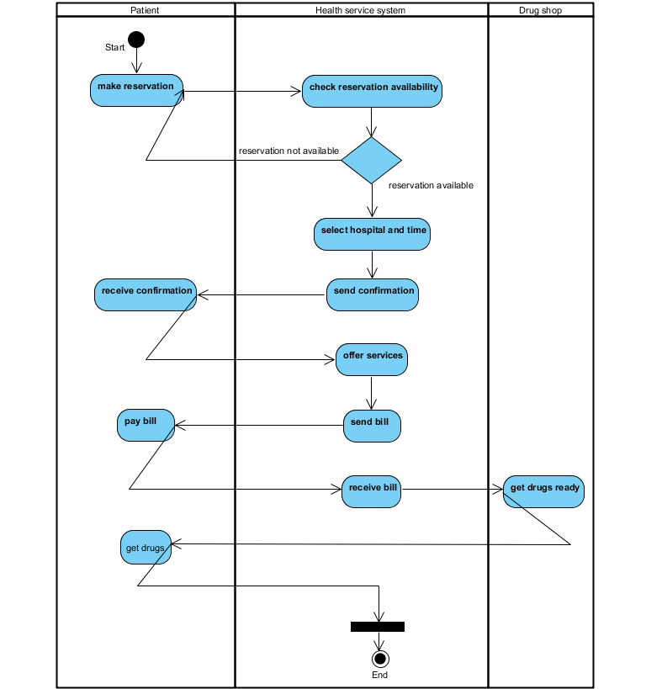

Figure 4.3 UML activity model of the health service system

## 4.3 The requirement model of Web-PHVA

It is noted again that the Web-PHVA is essentially an interface system (between the patient and service system). The requirement model for the Web-PHVA was developed by following Step 2 of the ICD methodology of Chapter 3. Particularly, the model of the Web-PHVA system is about what information or knowledge needs to be communicated with the user (i.e. the patient and doctor in this case) [Lin et al. 2006] as well as possible conditions for displaying the information or knowledge to the user.

The overall (required) functions of the Web-PHVA are: (1) to allow the patient to make a reservation (**FR-0.1**), (2) to arrange the patient to see doctor (**FR-0.2**), (3) to allow the patient to pay the fee for the service of doctor (**FR-0.3**), and (4) to allow the patient to get the drug prescribed by the doctor and delivered from the drug shop (**FR-0.4**). The notation related to FR can be noted: ‘0’ indicates the level; the number after the decimal point indicates the required function identity (the magnitude of the number does not imply the sequence of operations or actions). The general notation for **FR-i.j.k** is: *k* indicates the identity of a FR, *i*, *j* indicate the level in the hierarchy (i is higher than j). For instance, FR-0.1.2 means the function identity ‘2’ at the level ‘1’. Further, for FR-0.2, there are two condition or constraint requirements (CRs), namely the minimum waiting time of the outpatient (**CR-0.2.1**) and the minimum transportation time of the outpatient (**CR-0.2.2**). The notation of CR follows the notation of FR. In this study, both FR-0.3 and FR-0.4 were considered out of the scope.

FR-0.1 can be further decomposed based on the flow of service in Figure 4.1, and this leads to:

* **FR-0.1.1**: getting the patient’s general information, derived from (1) in Figure 4.1.
* **FR-0.1.2**: getting the important symptom of the patient, derived from (2) in Figure 4.1.
* **FR-0.1.3**: getting the special time window from the patient (i.e., **PRT** in Figure 4.1), derived from (5) in Figure 4.1.

FR-0.2 can be further decomposed based on the flow of service in Figure 4.1, and this leads to:

* **FR-0.2.1**: getting the location information of the patient, derived from (6a) in Figure 4.1. There is a constraint for this function: allowing the patient to change the location (**CR-0.2.1**).
* **FR-0.2.2**: assigning the patient to the hospital to determine the assigned time (AT) and the departure time (DT), derived from (6b) in Figure 4.1.
* **FR-0.2.3**: notifying the patient of the time to go to the hospital (i.e., AT and DT in Figure 4.1).
* **FR-0.2.4**: reminding the patient of the time to leave the location (DT), derived from (9) in Figure 4.1.

## 4.4 The architecture of the Web-PHVA

The architecture of the Web-PHVA was developed by following Step 3 of the ICD methodology in Chapter 3. The architectural element is denoted as DP (Design Parameter). DPs are supposed to achieve FRs (CRs if any), meaning that the DPs are the description of physical systems (i.e. hardware and software systems) to achieve FRs (CRs if any). For the interface system, DPs further represent gadgets or widgets on the interface media [Lin et al. 2006].

**DP-0.1** is a web-based interface system that allows the patient to have a dialogue with the service to make reservation to see doctor. **DP-0.2** is an interface system that includes the algorithm to assign a patient to a hospital such that, under the condition of the zero waiting time of outpatients in hospital, (1) the waiting time of the outpatient is as short as possible and (2) the transportation distance (from the location of the patient to the location of the hospital) is as short as possible.

DP-0.1 can be further decomposed into:

* **DP-0.1.1**: the interface element to get the patient’s information.
* **DP-0.1.2**: the interface element to get the patient’s symptom information.
* **DP-0.1.3**: the interface element to acquire the required time window to meet with the doctor from the patient.

DP-0.2 can be further decomposed into:

* **DP-0.2.1**: the interface element to get the patient’s location.
* **DP-0.2.2**: the element to assign the patient to the hospital.
* **DP-0.2.3**: the interface element to notify the patient of AT and DT.
* **DP-0.2.4**: the interface element to remind the patient of DT.

**Remark 1**: DP-0.2.2 is a scheduling algorithm to assign the patient to the hospital while at the same time to minimize the waiting time of outpatients (CR-0.2.1) and to minimize the transportation distance of outpatients (CR-0.2.2). The scheduling algorithm will be presented in Chapter 5.

**Remark 2**: The relationship between the DP and the domain model is as this. The DP is about the Web-PHVA but not about the work domain.

## 4.5 Conclusion with discussion

In this chapter, following Steps 1-4 of the ICD-methodology proposed in Chapter 3, the domain model of the service system was developed, the requirement model of the Web-PHVA system was derived and after that, the architecture of the Web-PHVA system was developed. It is noted that Step 4 of the ICD-methodology was not explicitly executed, as for the interface system, the derivation of DPs to meet FRs/CRs is very natural (or simply say, the mapping from FR to DP is an unit function). It is further noted that the design based on Step 5 of the ICD-methodology to the Web-PHVA system will be discussed in Chapter 6. Finally, with reference to the **first objective** of this thesis study, the Web-PHVA system is extendable, as the architecture is derived from the domain model. When the real world semantics change, a chain of changes will naturally follow: change of the domain model leads to change of the requirement model, which further leads to change of the architecture of the system.

# CHAPTER 5 SCHEDULING OF OUTPATIENTS

## 5.1 Introduction

In this chapter, the development of the algorithm to assign the patient to the hospital is discussed, which has the two objectives as mentioned before and revisited here, namely (1) making the waiting time of outpatients as short as possible, and (2) making the transportation distance of outpatients from their locations to the assigned hospitals as short as possible. Section 5.2 presents the description of this problem. Section 5.3 presents the assumption behind the mathematical model of this problem. Section 5.4 presents the mathematical model of the problem. Section 5.5 presents the solution (i.e., algorithm) to the mathematical model. Section 5.6 presents the results along with discussion. Finally, Section 5.7 concludes this chapter.

## 5.2 Problem description and general idea

The context of the problem is that there are several hospitals or medical centers in a town or region, and patients can see doctor in any hospital. Patients do not need to wait in hospitals but move around at their own liberty and communicate with the town’s health service system using their mobile device at any time. Patients communicate with the town’s health service system by expressing their required or desired time window to see doctor, their current locations, and their symptoms.

The algorithm solves the problem to assign patients to hospitals so as (1) to minimize the waiting time of outpatients with reference to their earliest desired time window to see doctor and (2) to minimize the transportation distance of outpatients from their current locations to the assigned hospitals.

**Remark 1**: The two objectives, as aforementioned above, may be in conflict. Therefore, the problem is a multi-optimization problem.

**Remark 2**: The zero waiting time of outpatients in hospitals was guaranteed by scheduling.

**Remark 3**: Suppose the current time is *t* (by current, it implies that there is a new patient who communicates with the health service system). All the patients who have already been reserved but not yet on the way to hospitals may be subject to changes if the total waiting time (by total, it is meant the sum of the waiting times of all the patients involved) and the total transportation distance (by total, it is meant the sum of the transportation distances of all the patients involved from their current locations to assigned hospitals) can be made shorter.

## 5.3 Problem assumption

**Assumption 1**: All the hospitals in the system are the same from a patient’s perspective except for their different locations. This assumption makes sense to the walk-in type of clinic center in Canada and makes sense to hospitals in China.

**Assumption 2**: The duration of time that patients meet with doctors are the same. This assumption is not unrealistic according to Entremont [2009]. Under this assumption, the duration of time that a patient meets with a doctor can be controlled in a fixed time period.

**Assumption 3**: All the patients and doctors are punctual. This assumption means that patients and doctors exactly follow the schedule made by the system.

## 5.4 Mathematical model

Notations used in the mathematical model are described as follows:

* a : the duration of time that patients see doctor.
* k : the number of hospitals.
* s : the number of patients who cannot be re-arranged.
* h : the number of patients who can be re-arranged.
* pn : the patient n.
* tpn : the time when patient n is making reservation with the system.
* sp : the average speed of the travel of the patient to the hospital.
* rdn : the required date of patient n.
* rn : the required time period of patient n, e.g., 3 – 4 pm.
* sprn : the lower bound of rn, e.g., 3 pm, or the earliest desired time of patient n.
* xn : the solution for patient n, where xn is an integer and xn ∈ [1, k].
* yn : the time for patient n to see doctor.
* dnj : the distance patient n drives to hospital j from his or her place and j∈[1, k].
* δ : the time the system will send a reminder to the patient for reservation.

Suppose that at time that patient n wants to see doctor. At this time, there are already n-1 patients who have been booked by the system. Note that the required or desired time window of patient n is given by patient n, i.e., rn.

First, the system needs to find out which patients can be re-arranged. This can be decided by

${tp}_{n}+d_{ij}/sp+δ≤y_{i}$ $\left(1≤i≤n-1\right)$ (5.1)

where tpn means the time patient n is making reservation in system, $d_{ij}/sp$ means the time that patient i needs to take to hospital j from his place; δ means the time segment (e.g., 15 minutes) for the system to remind the patient of his reservation – particularly to remind the patient of when the patient needs to go and when the patient sees doctor. Notice that yi is the time patient i sees doctor. There are two cases based on evaluation of the inequality (5.1): Case 1: Patient i does not meet the inequality, and this means that Patient i cannot be re-arranged. In this case, the time period of $\left[y_{i},y_{i}+a\right]$ for a particular hospital Patient i is supposed to visit (where a is the time period that the patient meets with the doctor) is occupied. Case 2: Patient i meets the inequality, and this means that Patient i can be re-arranged. In this case, the time period of $\left[y_{i}, y_{i}+a\right]$ for a particular hospital Patient i is supposed to visit (where a is the time period that the patient meets the doctor) can then be re-claimed for reservation. As such, at the time tpn, all the patients (1 to n) can be divided into two sets. Set *s*: the patients whose time cannot be re-arranged, denoted as $\left\{p_{1}, p_{2}, p_{3}, …, p_{s}\right\}$. Set *h*: the patients whose time can be re-arranged, denoted as $\left\{p_{1}, p_{2}, p_{3}, …, p_{h+1}, \right\},$ where s+h+1=n.

Second, the scheduling is taken on Set *h*, which means to determine xi and subsequently yi. It is noted that both xi and yi (where $i=1, 2, …, h, h+1;s+h+1=n$) are the decision variable. There are two objectives in this scheduling, namely:

OB-1: $Min\sum_{i=1}^{h+1}{\{y_{i} - {spr}_{i}\}}$ $\left(1≤i≤h+1\right)$ (5.2)

OB-2: $Min\sum_{i=1}^{h+1}{d_{ij}}$ $\left(1≤i≤h+1\right)$ $\left(1≤j≤k\right)$ (5.3)

The first one OB-1 is to minimize the total waiting time (the sum of the waiting time of each patient of the h+1 patients). The second one OB-2 is to minimize the total transportation distance (the sum of the transportation distance of each patient of the h+1 patients from his or her current location to the hospital assigned to him or her at time tpn). The two objectives may be in conflict, so the optimal scheduling problem here is a multi-objective optimal scheduling problem.

There are several constraints for this optimal scheduling problem. The first constraint is that the times that the patients meet the doctors have no conflict with each other. The second constraint is that the patients in the solutions have enough time to go to the hospitals. The mathematical expression for the first constraint includes:

1. For any patient $p_{l}∈\left\{p_{1}, p_{2}, p_{3}, …, p_{s}\right\}$, if $x_{i}=x_{l}$ then $\left[y_{i}, y_{i}+a\right]$ is not overlapping with $\left[y_{l}, y_{l}+a\right]$, i.e.,

$\left[y_{i}-\left(y_{l}+a\right)\right]×\left[\left(y_{i}+a\right)-y_{l}\right]≥0$ (5.4)

1. For any patient $p_{i}∈\left\{p_{1}, p_{2}, p_{3}, …, p_{h+1}\right\}$ and $p_{m}∈\left\{p_{1}, p_{2}, p_{3}, …, p_{h+1}\right\}$ $\left(i≠m\right)$, if $x_{i}=x_{m}$, then $\left[y_{i}, y_{i}+a\right]$ is not overlapping with $\left[y_{m}, y_{m}+a\right]$, i.e.,

$\left[y_{i}-\left(y_{m}+a\right)\right]×\left[\left(y_{i}+a\right)-y_{m}\right]≥0$ (5.5)

The mathematical expression for the second constraint is:

For any patient $p_{i}∈\left\{p_{1}, p_{2}, p_{3}, …, p_{h+1}\right\}$, there is

${tp}_{n}+d_{ij}/sp+δ≤y_{i}$ $\left(1≤i≤h+1\right)$ (5.6)

## 5.5 Algorithm

The mathematical model as described above has the following features: (1) a mix of discrete and continuous variables, (2) two categories of variables xi and yi with yi dependent on xi, (3) non-linear constraint and linear objective function, and (4) conflict in the objectives. To solve such an optimization problem, an improved non-dominated sorting genetic algorithm (NSGA-II) [Deb et al. 2002] was chosen. NSGA-II is a kind of the evolutionary algorithm for multi-objective optimization problems, and in particular it evolves from genetic algorithm [Mitchell 1996]. Other evolutionary algorithms may also work for the problem in this thesis, e.g., Pareto Archived Evolution Strategy (PAES) and Strength Pareto Evolutionary Algorithm (SPEA) [Deb et al. 2002]; but a detailed discussion is out of the scope of this thesis. Details of NSGA-II can be found in Appendix C. In applying NSGA-II, the following parameters need to be given, i.e., (a) the size of the population, (b) the crossover rate for simulated binary crossover, (c) the distribution index for simulated binary crossover, (d) the mutation rate for polynomial mutation, and (e) the distribution index for polynomial mutation. Definition of these parameters can be found in Appendix C.

## 5.6 Results with discussion

Suppose that there are three hospitals in a town. The parameters of the algorithm are given in Table 5.1. In the table, N is the number of decision variables.

Table 5.1 Parameters of the algorithm

|  |  |
| --- | --- |
| Parameter | Values |
| The size of the population  The crossover rate for simulated binary crossover  The distribution index for simulated binary crossover  The mutation rate for polynomial mutation  The distribution index for polynomial mutation | 100  1.0  15.0  1/N  20.0 |

Table 5.2 shows the results of the computational time of the NSGA-II algorithm. The first column is the number of patients; the second column is the number of tests; the third column is the running time (milliseconds). The running time was found as this. Each situation (refer to the number of patients) runs five times, and then the average running time was calculated. For instance, for the situation of 100 patients, the average running time was calculated as 686.2 milliseconds ((633+750+651+678+719)/5). Figure 5.1 shows the relation between the number of patients and the average running time, where the horizontal axis is the number of patients, and the vertical axis is the average running time. From Figure 5.1, it can be seen that (1) in general the computational time is practical, about five seconds for the situation that the number of patients on reservation is 60,000 (which is far more than most of the situations in a town or a city), (2) when the number of patients is around 15,000 (which is far more than most of the cities in Canada), less two seconds complete the scheduling, (3) there is indeed a big rise in the computational time for the number of patients being around 15,000 to 60,000, which shows that the optimal scheduling problem in this thesis has some sense of the exponential time complexity.

Figure 5.1 Computational time of NSGA-II

Table 5.2 Computational time of NSGA-II

|  |  |  |  |
| --- | --- | --- | --- |
| Number of patients | Test number | Running time (milliseconds) | Average running time (milliseconds) |
| 100  100  100  100  100 | 1  2  3  4  5 | 633  750  651  678  719 | 686.2 |
| 1000  1000  1000  1000  1000 | 1  2  3  4  5 | 801  779  828  784  782 | 794.8 |
| 3000  3000  3000  3000  3000 | 1  2  3  4  5 | 987  980  978  947  988 | 976 |
| 15000  15000  15000  15000  15000 | 1  2  3  4  5 | 1595  1589  1566  1597  1540 | 1577.4 |
| 60000  60000  60000  60000  60000 | 1  2  3  4  5 | 4582  4276  4252  4271  4224 | 4321 |

To validate the scheduling algorithm, a scenario was made. Suppose that (1) there were 3 hospitals in a town and (2) there were four patients who wanted to see doctor on a day and in a time period. Figure 5.2 shows the locations of the patients and locations of the hospitals. Table 5.3 gives the results of the scheduling algorithm. The meaning of each column in Table 5.3 is given as follows:

* rd means the date the patient required to visit the doctor.
* dp means the identity of the department of the hospital that the patient required to visit the doctor.
* p means the identity of the patient who requested the reservation.
* r means the time period that the patient required to visit the doctor.
* d1 means the distance between the patient and hospital 1.
* d2 means the distance between the patient and hospital 2.
* d3 means the distance between the patient and hospital 3.
* x means the identity of the hospital which is arranged by the scheduling algorithm.
* y means the time that the patient sees the doctor.

Hospital

Patient

P1

P2

P3

H1

H2

H3

Figure 5.2 The locations of the patients and hospitals

The following is the process of manual scheduling. P1 logins in the system at 8:00 am and he wants to see doctor at 9:00 am to 10:00 am. The distances of P1 to H1, H2, H3 are 3 km, 7.5 km, 9 km, respectively, and they can be translated into the travel time (suppose the travel rate is 20 km/h), which is 9 minutes, 22.5 minutes, 27 minutes, respectively. Suppose that the system is set to notify the patient 15 minutes prior to the departure of a patient. The time to send a reminder to P1 to H1, H2, H3 are 24 minutes, 37.5 minutes, 42 minutes, respectively, before the time P1 actually meets a doctor. The system arranges P1 to H1 and to meet a doctor at 9:00 am, because P1 is the first in the system. Further, the system will send a reminder to P1 at 8:36 am.

P2 logins in the system at 9:00 am and he wants to see doctor at 10:00 am to 11:00 am. The distances of P2 to H1, H2, H3 are 10.5 km, 3 km, 18 km, respectively (which further means that P2 needs 31.5 minutes, 9 minutes, and 54 minutes, respectively, to get to H1, H2, and H3 from his location). The system further gets that P2 needs to be reminded 46.5 minutes (to H1), 24 minutes (to H2), 69 minutes (to H3) before P2 actually meets the doctor. It is obvious that at this time, re-arrangement of P1 is not possible (in fact, at this time, P1 has already met the doctor). So the system then arranges P2 to H2 (which is closet to P2) and to meet the doctor at 10:00 am. The time for P2 has no conflict with the time for P1, and P2 will get a reminder from the system at 9:36 am.

P3 logins in the system at 9:15 am and he wants to see doctor at 11:00 am to 12:00 am. The distances of P3 to H1, H2, H3 are 12 km, 16.5 km, 3 km, respectively (which further means P3 needs 36 minutes, 49.5 minutes, 9 minutes to get to the three hospitals, respectively). Further, P3 gets a reminder 51 minutes (to H1), 64.5 minutes (to H2), 24 minutes (to H3) before P3 actually meets a doctor. At this point of time (i.e., 9:15 am), P2 can be re-arranged, as the time to send a reminder to him is 9:36 am. Therefore, the system re-arranges P2 and P3 simultaneously. P2 and P3 do not have any conflict in their required time windows to see doctors, so the system arranges P2 to H2 and to meet doctors at 10:00 am and arranges P3 to H3 and to meet the doctor at 11:00 am. In fact, the schedule for P2 has no change.

The above manual scheduling gets the same result of Table 5.3 (see the x-column and y-column). Therefore, the scheduling algorithm is valid. It is noted that the waiting times of P1, P2, and P3 are all zero in this example, as opposed to the average waiting time of 2 hours or more according to the literature **[Blendon et al. 2004]**.

Table 5.3 Reservation records example

|  |  |  |  |  |  |  |  |  |
| --- | --- | --- | --- | --- | --- | --- | --- | --- |
| rd | dp | p | r | d1 | d2 | d3 | x | Y |
| 2015-11-22  2015-11-22  2015-11-22 | 1  1  1 | 1  2  3 | 9:00-10:00  10:00-11:00  11:00-12:00 | 3 | 7.5 | 9 | 1 | 9:00 |
| 10.5  12 | 3  16.5 | 18  3 | 2  3 | 10:00  11:00 |

## 5.7 Conclusion

In this chapter, the problem of the scheduling of patients to hospitals was discussed. The optimal scheduling problem has two conflicting objectives (the minimal waiting time and minimal transportation distance). The problem can be modeled as a constrained multi-objective optimization problem. NSGA-II was employed to solve this problem with a great success. The algorithm has been shown practically feasible in terms of computation time, and the algorithm has also been proved to be valid.

# CHAPTER 6 DEMONSTRATION SYSTEM: VALIDATION

## 6.1 Introduction

In this chapter, a demonstration (demo) system is presented to validate the whole system (Web-PHVA). It is noted that not a full spectrum of features of the system is demonstrated but to give a look-and-feel of the system when it is fully implemented in the future. In the remaining part of the chapter, Section 6.2 presents the architecture of the demo system. Section 6.3 presents the implementation of the demo system – in particular the layout of the gadgets or widgets (as the Web-PHVA system is essentially an interface system) based on Step 5 of the ICD-methodology in Chapter 3. Section 6.4 presents the scenario for the demo system, which is the example used to validate the scheduling algorithm in Chapter 5 (Section 5.6 in particular).

## 6.2 Conceptual design of the demo system of Web-PHVA: revisiting

It is noted that from a system design perspective, the term ‘design parameter’ (DP) is used, while from an interface design perspective, the term ‘gadget or widget’ is used. In this section, the term (gadget or widget) is used for re-visiting the conceptual design of the Web-PHVA system in Chapter 4, and it is also understood that the gadget or widget corresponds to the DP in Chapter 4.

There are seven gadgets in the interface, and they are: (1) Patient’s information, (2) Patient’s symptom information, (3) Required time window, (4) Patient’s location detection, (5) Scheduling of the patient to the hospital, (6) Notifying to the patient, and (7) Reminding the patient of departure. Gadget-1 is used to receive patient’s information. Gadget-2 is used to receive patient’s symptom information. Gadget-3 is used to receive patient’s required time to meet with the doctor. Gadget-4 is used to get patient’s location. Gadget-5 is used to assign patient to the hospital. Gadget-6 is used to notify the patient of AT and DT. Gadget-7 is used to remind patient of DT.

The relationships among the gadgets are: (1) Gadget-1, Gadget-2 and Gadget-3 are to acquire information from patients. (2) The information in Gadget-5 is dependent on the information from Gadget-3 and Gadget-4, which provides a schedule for patients. (3) Gadget-6 and Gadget-7 are to notify patients of the information. (4) Gadget-6 and Gadget-7 will send information to patients of the results of Gadget-5.

## 6.3 The layout for the Web-PHVA system

This section design the layout and detailed design of the Web-PHVA system by following Step 5 of the ICD-methodology in Chapter 4, particularly the proximity compatibility principle which is in a narrow context that is display design, as first proposed in [Wickens & Carswell 1995] and re-elaborated with the new term called cognitive compatibility in [Xue et al. 2015]. Figure 6.1 shows the layout of Gadget-1 and Figure 6.2 shows the detailed design of Gadget-1. Figure 6.3 shows the layout of Gadget-2 and Gadget-3. Figure 6.4 shows the detailed design of Gadget-2 and Gadget-3. Gadget-4, Gadget-5, Gadget-6 and Gadget-7 do not necessarily take the format of display but the format of audio (e.g., to make a phone call to the patient or send a message to the patient).

Web-PHVA

Navigation

Gadget-1

Figure 6.1 Layout of Gadget-1

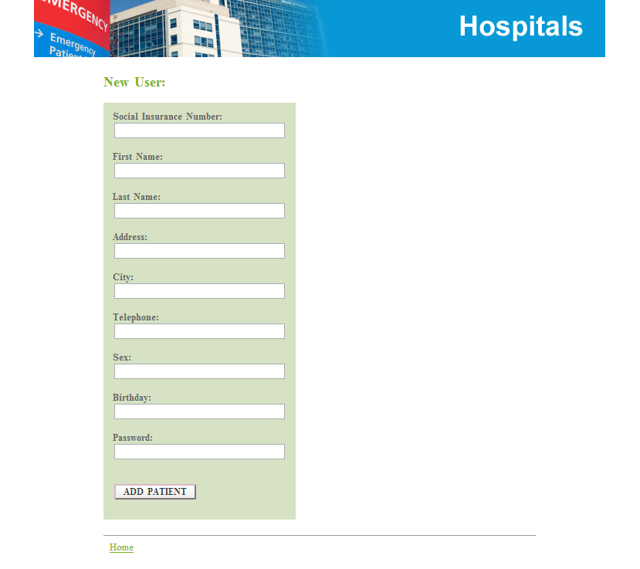

Figure 6.2 Detailed design of Gadget-1

Web-PHVA

Navigation

Gadget-2 and Gadget-3

Figure 6.3 Layout of Gadget-2 and Gadget-3

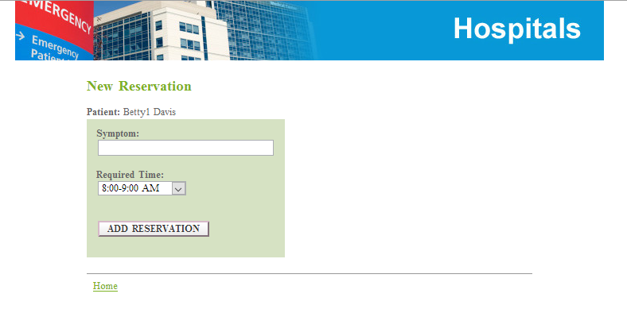

Figure 6.4 Detailed designs of Gadget-2 and Gadget-3

## 6.4 The scenario of the Web-PHVA

The scenario of the Web-PHVA is as follows (the same as the one in Section 5.6): (1) There are three hospitals in a city, which have the same service level but are in different locations; (2) The time period for outpatients to see doctor are the same which is 15 minutes; (3) All outpatients and doctors are punctual, which means they exactly follow the schedule made by Web-PHVA; (4) All outpatients drive to hospitals with the same travel rate or speed; (5) The average speed of outpatients to hospitals is 20 km/h; (6) The system will remind the patient of the time to departure 15 minutes in advance.

The agent-based simulation development tool called AnyLogic was used to implement the above scenarios. The development tool allows the user to specify the space and time configuration of entities. In this thesis, these entities are: hospitals, patients. Figure 6.5 presents the scenario of the locations of three patients and three hospitals in a city which exactly corresponding to Figure 5.2 in Chapter 5. Figure 6.6 shows the movements of the three patients following the schedule determined by the Web-PHVA system. Figure 6.7 shows the schedule in the system. In the “time” column, 15 represents 3:00 pm. 10 represents 10:00 am and 14 represents 2:00 pm. These times are exactly the same as the times for the three patients to see doctor. The dynamics of the three patients as well as their communication activities with the Web-PHVA system is the same as the one presented in Section 5.6.

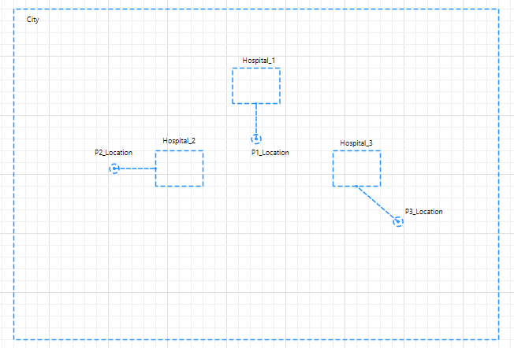

Figure 6.5 Locations of patients and hospitals in a city

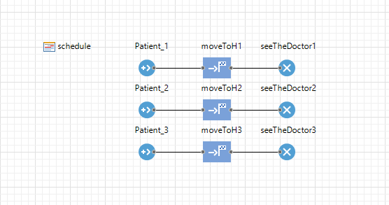

Figure 6.6 The movements of the patients

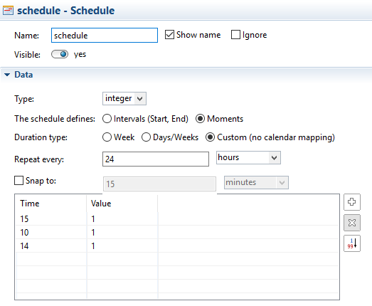

Figure 6.7 Schedule of the patients

# CHAPTER 7 CONCLUSION

## 7.1 Overview

This thesis presented a study to (1) reduce the waiting time of outpatient with reference to his or her desired time window and zero waiting time in hospitals or medical centers or clinic centers and (2) reduce the fuel consumption of the transportation of the patient to the hospital. The long waiting time of patients is notoriously a problem in every place in the world.

The preliminary study made the author believe that the solution to the problem can be addressed by developing a web-based (interface) system. The system is called Web-PHVA. The system interacts with patients who may be mobile at home or at office to make schedule for the patient and to inform the patient of the schedule. The specific objectives of the study include:

* **Objective 1**: to develop the architecture of such a web-based (interface) system with the goal that the system is extendable.
* **Objective 2**: to develop an algorithm for the assignment of the patients to the hospital to reduce both the waiting time of outpatients and the transportation time of outpatients from a particular location to a particular hospital with the goal that the algorithm is scalable.
* **Objective 3**: to build a demonstration system to validate both the web-based interface system concept and the assignment algorithm.

Additionally, the preliminary study also revealed that there was lack of a systematic approach to develop such a web-based interface system (note that such systems can be generated to the interface system of cybernetic systems). Therefore, this thesis also looked into the methodology to design the interface system for cybernetic systems.

These objectives had found achievable with the following details. Chapter 2 presented a comprehensive review of the literature to further justify the proposed objective. A new design methodology to the interface system of cybernetic systems was presented in Chapter 3, which achieved the additional objective. Chapter 4 presented the conceptual design of the Web-PHVA system by following the methodology developed in Chapter 3, which achieved Objective 1. A scheduling algorithm was developed in Chapter 5, which included a multi-objective optimization model for the problem and an evolutionary computing algorithm to solve the model. The work in Chapter 5 achieved Objective 2. In Chapter 6, a demonstration system was described to validate both the interface system (in Chapter 4) and the algorithm (in Chapter 6), which achieved Objective 3.

Several conclusions can be drawn from this study: (1) The waiting time of outpatients can be significantly reduced, from several hours to several minutes. (2) The proposed design methodology for the web-based interface system for cybernetic systems is effective in that the architecture of the interface designed based on this methodology is extendable. (3) The algorithm for the scheduling problem in this study is practically useful, as the running time is very short.

## 7.2 Contributions

There are several contributions of this thesis. First, in the field of software system development, the proposed methodology for the web-based interface system of cybernetic systems is new and promising. The methodology actually combines the interface design methodology and system design theory and methodology such as FCBPSS, ADT, and SDP. Second, in the field of operation management, the mathematical model along with the algorithm to solve the model has some salient features. It can be used for solving other types of the problems of the waiting time of patients by scheduling, e.g., the waiting time of patients in emergency room, for which one may only need to change the required time window of patients to see doctors.

In healthcare, this thesis has demonstrated the possibility to reduce the waiting time of outpatients from hours to minutes as well as fuel consumption and traffic congestion in hospitals (because patients arrive at hospitals in the just-in time manner).

## 7.3 Future work

Several future endeavors could potentially improve this thesis work. First, the Web-PHVA needs to be further developed into a commercial product. Second, several assumptions in the problem model and mathematical model can be lift for a more accurate model of the problem of the long waiting time of patients.

REFERENCES

Balasubramanian, H., Banerjee, R., Denton, B., Naessens, J., & Stahl, J. (2010). Improving clinical access and continuity through physician panel redesign. Journal of general internal medicine, 25(10), 1109-1115.

Barlow, G. L. (2002). Auditing hospital queuing. Managerial Auditing Journal, 17(7), 397-403.

Bhatta, S. R., & Goel, A. K. (1994). Discovery of physical principles from design experiences. Artificial Intelligence for Engineering, Design, Analysis and Manufacturing, 8(02), 113-123.

Bi, Z. M., Lin, Y., & Zhang, W. J. (2010). The general architecture of adaptive robotic systems for manufacturing applications. Robotics and Computer-Integrated Manufacturing, 26(5), 461-470.

Bielen, F., & Demoulin, N. (2007). Waiting time influence on the satisfaction-loyalty relationship in services. Managing Service Quality: An International Journal, 17(2), 174-193.

Blendon, R. J., Schoen, C., DesRoches, C. M., Osborn, R., Zapert, K., & Raleigh, E. (2004). Confronting competing demands to improve quality: a five-country hospital survey. Health Affairs, 23(3), 119-135.

Bolton, S.C. (2002), “Consumer as king in the NHS”, The International Journal of Public Sector Management, Vol. 15 No. 2, pp. 129-39.

Bowers, J., Ghattas, M., & Mould, G. (2012). Exploring alternative routes to realizing the benefits of simulation in healthcare. Journal of the Operational Research Society, 63(10), 1457-1466.

Chandrasekaran, B., & Josephson, J. R. (2000). Function in device representation. Engineering with computers, 16(3-4), 162-177.

Clague, J. E., Reed, P. G., Barlow, J., Rada, R., Clarke, M., & Edwards, R. H. (1997). Improving outpatient clinic efficiency using computer simulation. International Journal of Health Care Quality Assurance, 10(5), 197-201.

Deb, K., Pratap, A., Agarwal, S., & Meyarivan, T. A. M. T. (2002). A fast and elitist multi-objective genetic algorithm: NSGA-II. Evolutionary Computation, IEEE Transactions on, 6(2), 182-197.

Entremont, B. “Clinical Pathways: The Ottawa Hospital Experience - Future Direction”, (2009). [Online]. Available at <https://canadian-nurse.com/en/articles/issues/2009/may-2009/clinical-pathways-the-ottawa-hospital-experience>.

Fan, L. X., Cai, M. Y., Lin, Y., & Zhang, W. J. (2015). Axiomatic design theory: further notes and its guideline to applications. International Journal of Materials and Product Technology, 51(4), 359-374.

Forsberg, H. H., Aronsson, H., Keller, C., & Lindblad, S. (2011). Managing health care decisions and improvement through simulation modeling. Quality Management in Healthcare, 20(1), 15-29.

Gero, J. S. (1990). Design prototypes: a knowledge representation schema for design. AI magazine, 11(4), 26.

Gorman, A. “Avoid The Rush! Some ERs Are Taking Appointments”, (2014). [Online]. Available at: http://www.npr.org/blogs/health/2014/09/23/348756549/avoid-the-rush-some-ers-are-taking-appointments.

Hayes, K. J., Eljiz, K., Dadich, A., Fitzgerald, J. A., & Sloan, T. (2015). Trialability, observability and risk reduction accelerating individual innovation adoption decisions. Journal of health organization and management, 29(2), 271-294.

Healthcare Performance Partners. “Hospital Improves Diagnostics Registration

Time, Satisfaction, and Productivity”, (2010). [Online]. Available at: http://www.leanhealthcareexchange.com/wp-content/uploads/2011/03/HPP_CaseStudy_Diagnostics_Registration.pdf.

Hintersteiner, J. D., & Nain, A. S. (August, 1999). Integrating software into systems: an axiomatic design approach. In The Third International Conference on Engineering Design and Automation (pp. 1-4).

Istqb exam certification. “What is Prototype model- advantages, disadvantages and when to use it?” (2016). [Online]. Available at <http://istqbexamcertification.com/what-is-prototype-model-advantages-disadvantages-and-when-to-use-it/>.

Jin, X., Sivakumar, A. I., & Lim, S. Y. (2013). A simulation based analysis on reducing patient waiting time for consultation in an outpatient eye clinic. 2013 IEEE Simulation Conference (WSC), Issue Date: 8-11 Dec 2013, 2192-2203.

Kaushal, A., Zhao, Y., Peng, Q., Strome, T., Weldon, E., Zhang, M., & Chochinov, A. (2015). Evaluation of fast track strategies using agent-based simulation modeling to reduce waiting time in a hospital emergency department. Socio-Economic Planning Sciences, 50, 18-31.

Kim, S. J., Suh, N. P., & Kim, S. G. (1991). Design of software system based on axiomatic design. CIRP Annals-Manufacturing Technology, 40(1), 165-170.

Kujala, J., Lillrank, P., Kronström, V., & Peltokorpi, A. (2006). Time-based management of patient processes. Journal of Health Organization and Management, 20(6), 512-524.

Lailomthong, N., & Prichanont, S. Patient’s Waiting Time Reduction in Outpatient Department.

Lin, Y., & Zhang, W. J. (2004). Towards a novel interface design framework: function–behavior–state paradigm. International journal of human-computer studies, 61(3), 259-297.

Lin, Y., Zhang, W. J., Koubek, R. J., & Mourant, R. R. (2006). On integration of interface design methods: Can debates be resolved?. Interacting with Computers, 18(4), 709-722.

Liu, CJ, Lin, Y., Teng, H., Wang, Z.D., Zhang, W.J., 2013. An Experimental Study on three General Interface Layout Designs for Chemical Process Plants. Human Factors and Ergonomics in Manufacturing & Service Industries. DOI: 10.1002/hfm.20564.

Mitchell, M. (1996). An introduction to genetic algorithms, 1996. PHI Pvt. Ltd., New Delhi.

Multitier architecture. In Wikipedia. Retrieved November 23, 2015, from https://en.wikipedia.org/wiki/Multitier_architecture.

Pahl, G., Beitz, W., & Feldhusen, J. (1984). Engineering Design. The Design Council, London.

Pillay, D. I. M., Ghazali, R. J. D. M., Manaf, N. H. A., Abdullah, A. H. A., Bakar, A. A., Salikin, F. & Ismail, W. I. W. (2011). Hospital waiting time: the forgotten premise of healthcare service delivery? International journal of health care quality assurance, 24(7), 506-522.

Sampath, M. “A comparison of axiomatic design theory and systematic design procedure in the design of a solid state fermenter.” (2014). [Online]. Available at: <http://ecommons.usask.ca/bitstream/handle/10388/ETD-2014-09-1763/MUDDADA-THESIS.pdf?sequence=3>.

Shin, G. S., Yi, J. W., Yi, S. I., Kwon, Y. D., & Park, G. J. (2005). Calculation of Information Contents in Axiomatic Design. Journal of the Korean Society for Precision Engineering, 22(6), 183-191.

Stamatis, D. H. (2002). Six sigma and beyond: design for six sigma (Vol. 6). CRC Press.

Suh, N. P. (1990). The principles of design (Vol. 990). New York: Oxford University Press.

Suh, N. P. (2001). Axiomatic Design: Advances and Applications (The Oxford Series on Advanced Manufacturing).

Suh, N. P. (2005). Complexity: theory and applications. Oxford University Press on Demand.

Uehira, T., & Kay, C. (2009). Using design thinking to improve patient experiences in Japanese hospitals: a case study. Journal of Business Strategy, 30(2/3), 6-12.

Umeda, Y., Takeda, H., Tomiyama, T., & Yoshikawa, H. (1990). Function, behavior, and structure. Applications of artificial intelligence in engineering V, 1, 177-194.

Unified Modeling Language. In Wikipedia. Retrieved January 12, 2015, from <http://en.wikipedia.org/wiki/Unified_Modeling_Language>.

Waterfall model. In Wikipedia. Retrieved January 11, 2016, from https://en.wikipedia.org/wiki/Waterfall_model.

Wang, J. W., Wang, H. F., Zhang, W. J., Ip, W. H., & Furuta, K. (2014). On a unified definition of the service system: What is its identity? IEEE Systems Journal, 8(3), 821-826.

White, D. L., Froehle, C. M., & Klassen, K. J. (2011). The effect of integrated scheduling and capacity policies on clinical efficiency. Production and Operations Management, 20(3), 442-455.

Wickens, C. D., & Carswell, C. M. (1995). The proximity compatibility principle: its psychological foundation and relevance to display design. Human Factors: The Journal of the Human Factors and Ergonomics Society, 37(3), 473-494.

Wieczner, J. “10 Things Drugstores Won't Tell You”, (2013). [Online]. Available at <http://www.wsj.com/articles/SB10001424127887324077704578360492527284364>.

Xue, L., C.J. Liu, Y. Lin, Zhang, W. J. (2015). On redundant human-robot interface: Concept and design principle. Advanced Intelligent Mechatronics (AIM), 2015 IEEE International Conference on, Issue Date: 7-11 July 2015, 287-292.

Zhang, L. “The usual process of seeing a doctor in a Chinese Hospital”, (2012). [Online]. Available at: <http://www.shanghaiexpat.com/phpbbforum/the-usual-process-of-seeing-a-doctor-in-a-chinese-hospital-t143753.html#p1739955>.

Zhang W.J. (1994). An Integrated Environment for CADCAM of Mechanical Systems, Ph.D. thesis, printed by Delft University of Technology, The Netherlands, ISBN 90-370-0113-0, pp. 1-263.

Zhang, W. J., Li, J. W., & Zettl, B. (2012, July). Classification of design theories and methodologies for effective industrial applications. In Industrial Electronics and Applications (ICIEA), 2012 7th IEEE Conference on (pp. 1255-1260).

Zhang, W. J., Lin, Y., & Sinha, N. (2011). On the function-behavior-structure model for design. Proceedings of the Canadian Engineering Education Association.

Zhu, Z., Heng, B. H., & Teow, K. L. (2012). Analysis of factors causing long patient waiting time and clinic overtime in outpatient clinics. Journal of medical systems, 36(2), 707-713.

APPENDIX A

Unified modeling language (UML)

The Unified Modeling Language (UML) is a general-purpose modeling language for specification of a software system [“Unified Modeling Language” 2015]. The specification covers: (1) Components of the system, (2) Interfaces between any two components, (3) Activities of the components, (4) Interfaces with external components, and (5) How the system is expected to be used. The UML was originally developed based on the object-oriented software system development paradigm, and now it covers all the aspects of a software system. As a language, UML has both the textural format and diagrammatic format. Its diagrammatic format is especially attractive, as it can facilitate the human-human communication along the process of developing a piece of software. Diagrams of the UML can be categorized into Figure A.1 [“Unified Modeling Language” 2015]. Details of them are referred to the literature [“Unified Modeling Language” 2015].

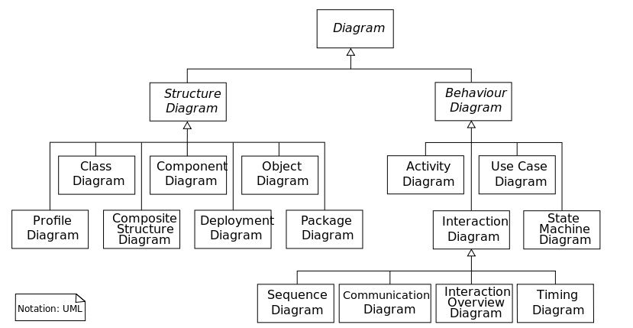

Figure A.1 Categorized diagrams in UML [“Unified Modeling Language” 2015]

APPENDIX B

Design Theory and Methodology

Two design approaches are outlined in this appendix, namely Axiomatic Design Theory (ADT) and Systematic Design Process (SDP).

ADT is a design theory and methodology for system design [Suh 1990, 2001, 2005, Stamatis 2002, Fan et al. 2015]. It starts with the specification of the required function of a system under design and the required condition upon which the required function will be played by the system. The required function is denoted as FR (function requirement), and the required condition is denoted as CR (condition requirement or context requirement). Then, the description of a system under design is proposed to fulfil FR and CR. The description is denoted as DP (design parameter) which captures the feature of a design entity.

In ADT, once DP cannot be found to fulfill FR, the FR needs to be decomposed to sub-FR and to seek sub-DP which fulfills sub-FR. Such a decomposition process will proceed until all FRs (including sub-FRs) are fulfilled by DPs (sub-DPs). This process is also called zig-zag process (Figure B.1). There are two axioms with ADT.

Axiom 1: The Independence Axiom.

Axiom 2: The Information Axiom (out of the scope of this thesis).

In short, Axiom 1 states that FRs should be independent and DPs should maintain the independency of FRs. Therefore, Axiom 1 can serve as a check point for DPs proposed to fulfill FRs.

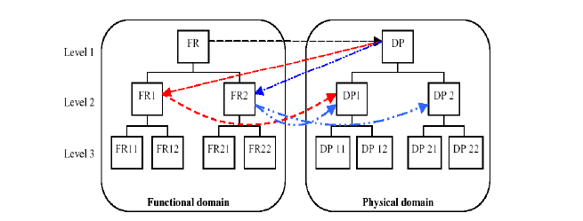

Figure B.1 Hierarchical systems of the functional requirements and design parameters [Shin et al. 2005]

SDP [Pahl et al. 1984] is a design approach with a focus on (1) generating FRs and (2) generating DPs. With reference to Figure B.1, SDP attempts to find DPs from FRs and to define DPs to be compatible to one another. The compatibility must be based on a criterion or criteria. In the original version of SDP [Pahl et al. 1984], the criterion is more in the sense of physical, that is, two DPs must be physically compatible. However, criteria are of many types, notably the perceptual and cognitive compatibility [Liu et al. 2015].

APPENDIX C

NSGA-II

Non-dominated sorting genetic algorithm II (NSGA-II) is evolved from the genetic algorithms (GA) to have a capability to solve multi-objective optimization problems [Deb et al. 2002]. Java implementation of NSGA-II can be accessed from the following web link.

http://moeaframework.org/

The procedure to use this program is as follows:

* Step 1. Set the number of variables, objectives and constraints.
* Step 2. Input the information of patients in the system.
* Step 3. Set each variable and the constraint, respectively.
* Step 4. Set each objective respectively.
* Step 5. Set each constraint respectively.
* Step 6. In the main method, choose the algorithm as “NSGAII” and run the algorithm.
* Step 7. Print the result.

There are several parameters that need to be determined by the user in order to use NSGA-II which can be found from the manual of the Java implementation of NSGA-II and the manual can be downloaded from the following web link.

<http://moeaframework.org/downloads.html>

These parameters are:

* The size of the population: the number of individuals (i.e., solutions) in a population.
* The crossover rate for simulated binary crossover: a ratio of how many couples will be picked for mating for the process of the simulated binary crossover.
* The distribution index for simulated binary crossover: the breadth of the molecular weight distribution for the simulated binary crossover.
* The mutation rate for polynomial mutation: how often parts of the chromosome could be mutated.
* The distribution index for polynomial mutation: the breadth of the molecular weight distribution for polynomial mutation.

These parameters need to be determined by the user through the module called “setProperty”.